DevOps Micro Internship (DMI) — Cohort 2

Week 12 Assignment: Ansible for DevOps Engineers

Full Name
LinkedIn Profile (public URL)
Group | (to be assigned)
Country / Timezone
Submission Date

File name format (required): FullName_Week9_GroupX (Example: PravinMishra_Week9_Group3)
Before you submit: Ensure links are public & clickable, then upload

Purpose (read this first)
- Set up a complete Agentic AI DevOps workflow with Claude Code
- Teach AI your project, deploy with skills, and use subagents + MCP with safety controls
- Build production-style evidence and a public professional portfolio from your work

Expectations:
- Be practical and evidence-based (screenshots).
- Write short, clear explanations (adult professional writing).
- Follow instructions exactly (mentors evaluate based on proof).
- Your work must be verifiable and reproducible.

PROOF RULE (VERY IMPORTANT)
Your FULL NAME must appear in EVERY screenshot you submit.
How to ensure your full name appears:
- If the online page or tool already shows your name → perfect (capture it).
- If it does not show your name → show your name on the screen using ANY simple method:
  - open a Notepad/Notes window with your Full Name, OR
  - open a text file with your Full Name, OR
If your screenshot does not clearly show your Full Name, it will be rejected.
Privacy rules:
- Blur your email address and account ID if visible.
- Do NOT blur your Full Name.

Assignment 1: Onboarding — Workstation Setup, Standards & AI (Go Beyond)

Notes should include:
What you did (2–5 lines per task)
What you learned (1–2 lines)
Any issue you faced + how you solved it (if applicable)

Task 1
Notes:
Screenshots: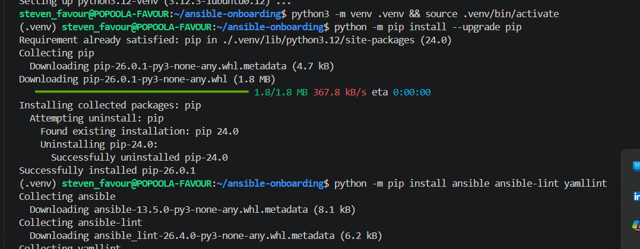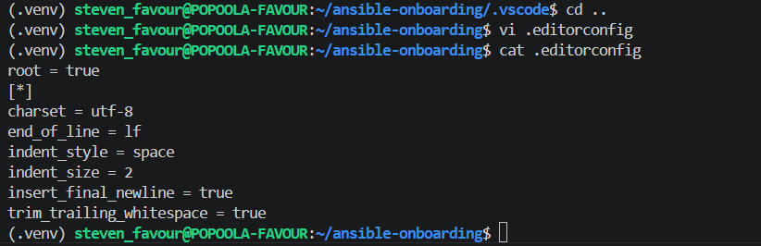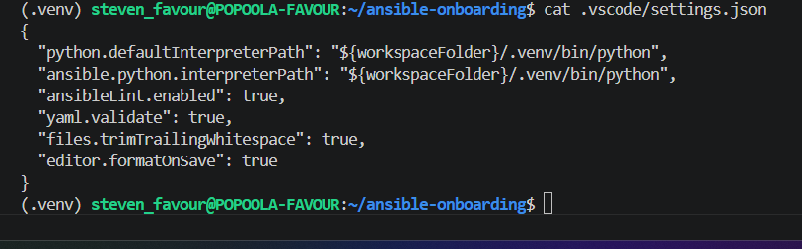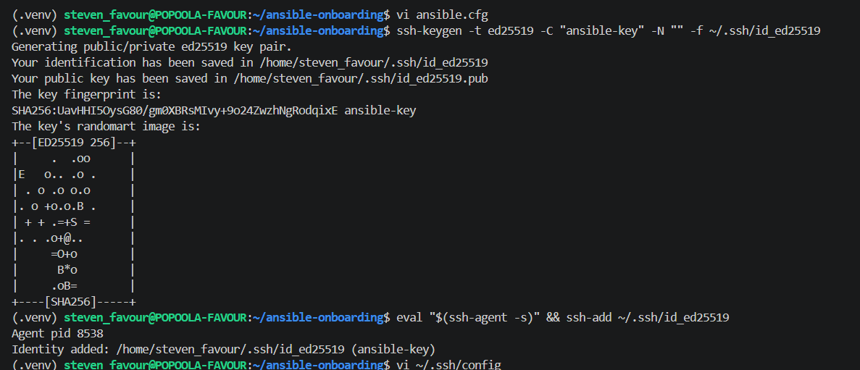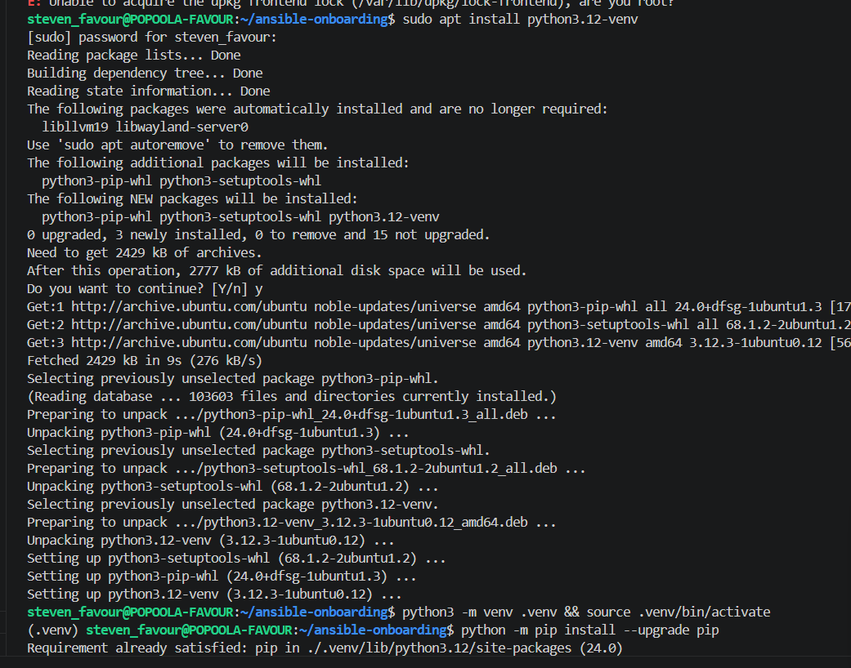

Task 2
Notes:
Screenshots: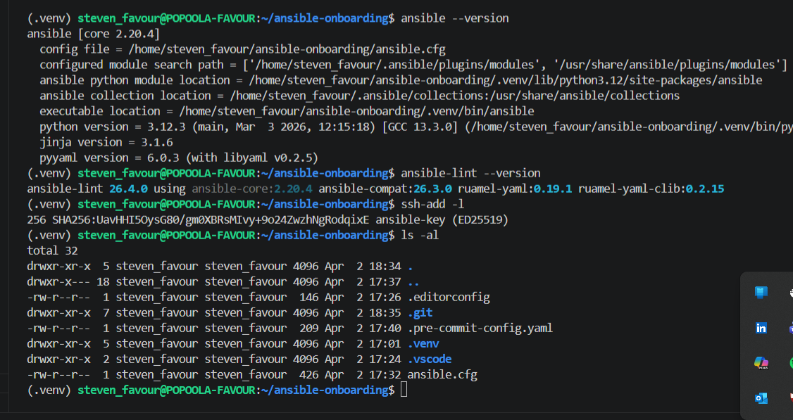
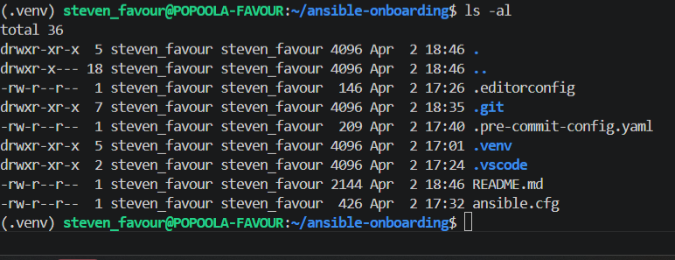

Task 3
Notes:
Screenshots:

Assignment 2: Ad-Hoc Automation on Azure — 4 VMs, Inventory & Passwordless SSH
Notes should include:
What you did (2–5 lines per task)
What you learned (1–2 lines)
Any issue you faced + how you solved it (if applicable)

Task 1
Notes:
Screenshots: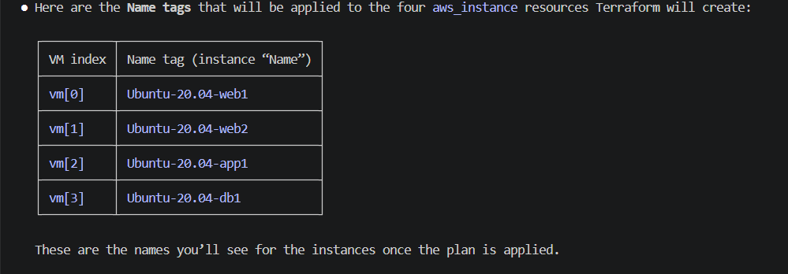
Terraform with ClaudeAI used to plan the four vms to be provisioned
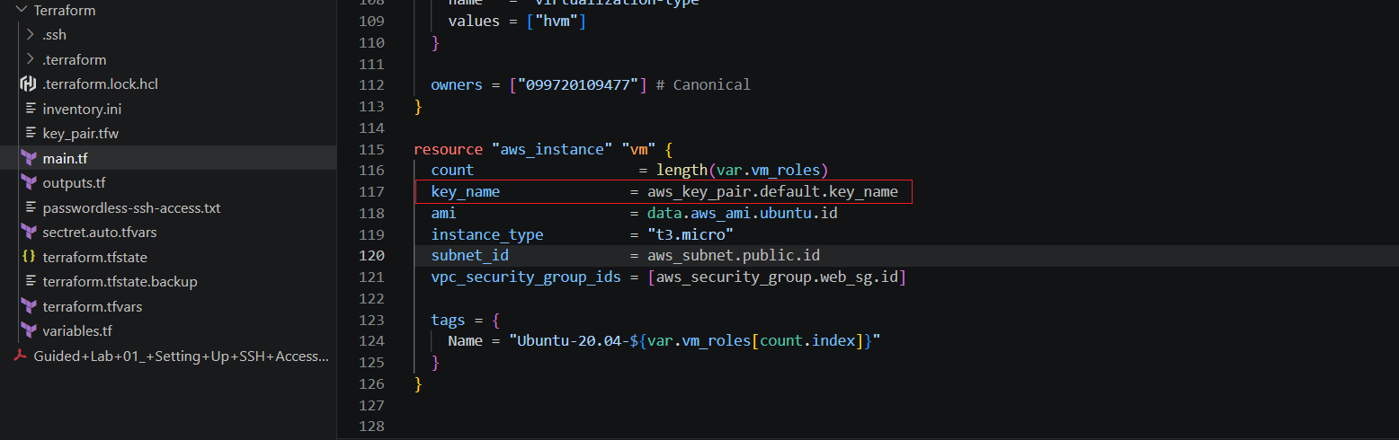Key_name was then used to pass the public key to the 4 vms upon launching.
AWS does not permit passwordless access to instances when launching.
Terraform Apply completed.
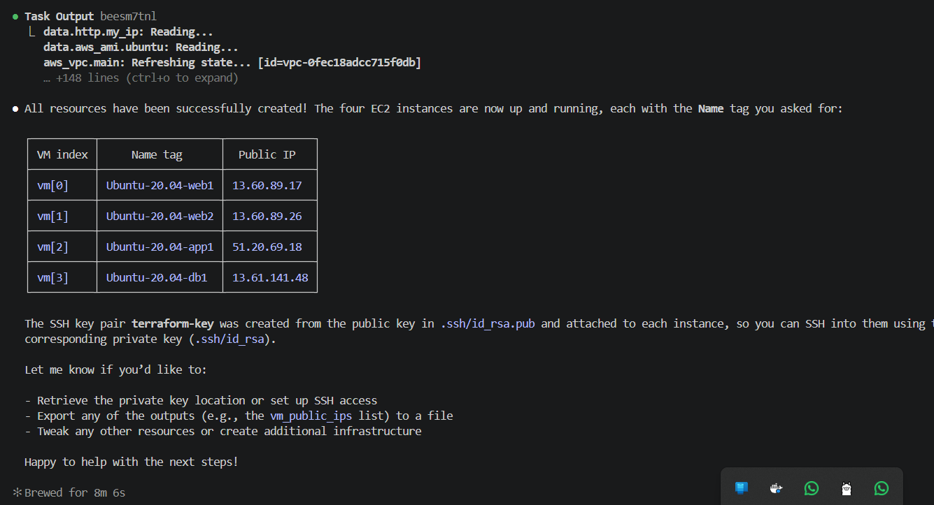
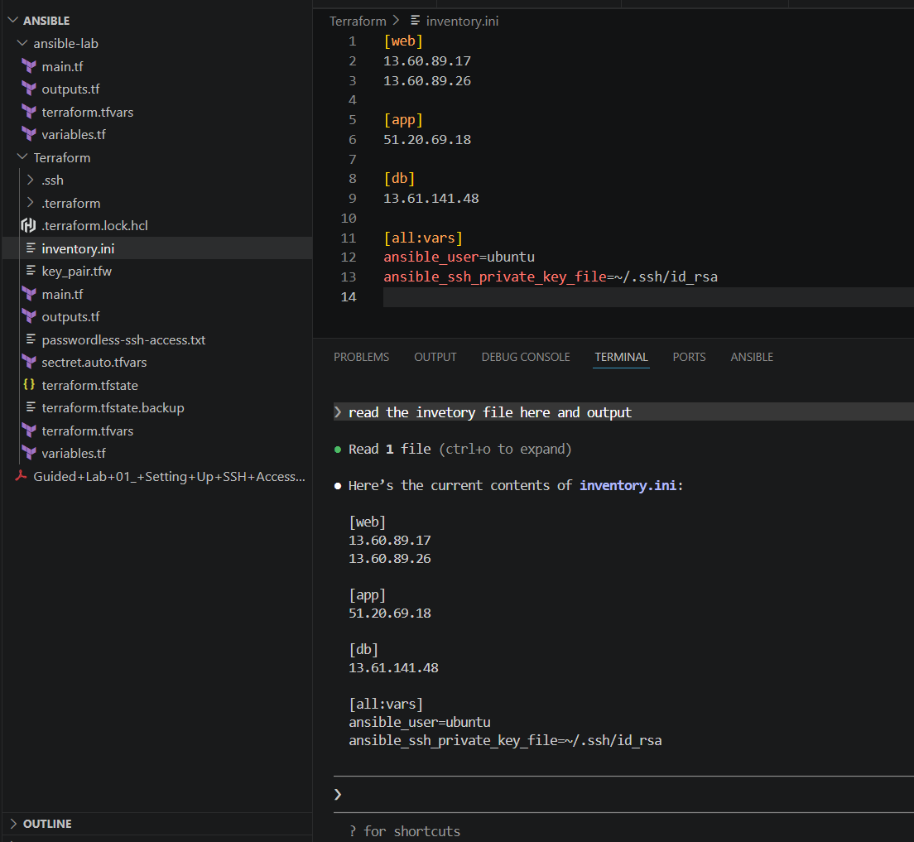

Inventory.ini created and modified.

Task 2
Notes:
Screenshots:
Run Ping command on all the vms using ansible form the controller node (local machine)
Summary shows SUCCESS.

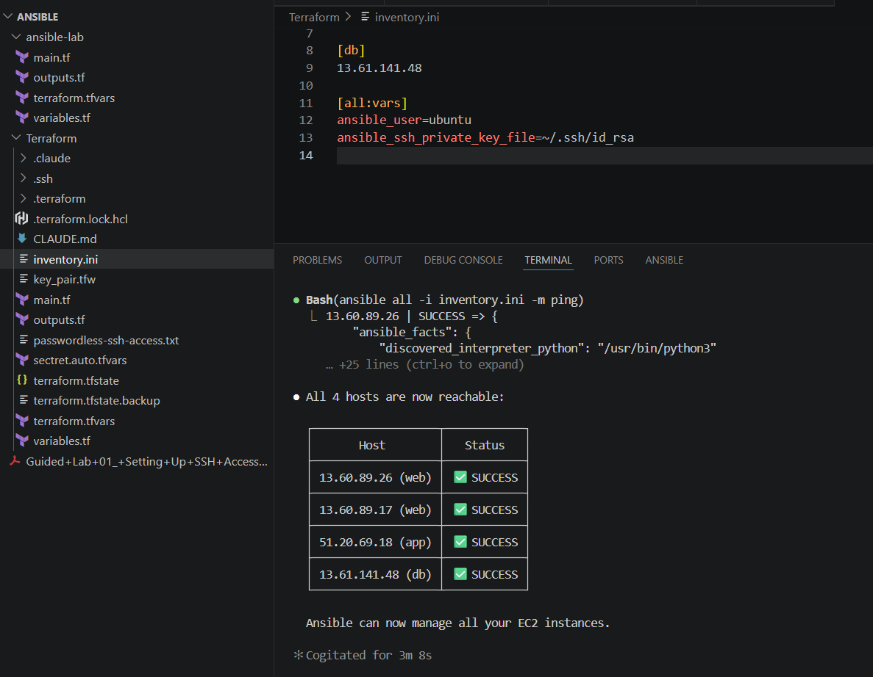

Before installing nginx, apt-update need to run to update packeges.

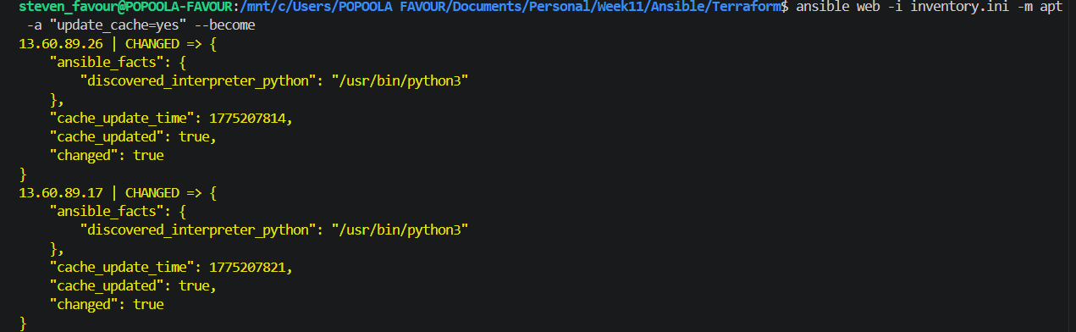

After success, we install nginx on both servers in the web group
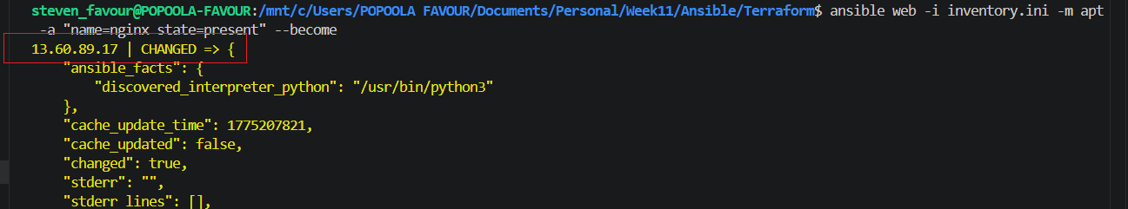
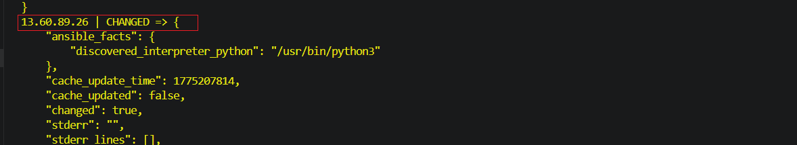

Then enable nginx
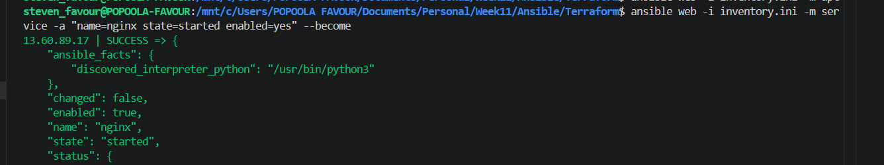

Install htop using apt module
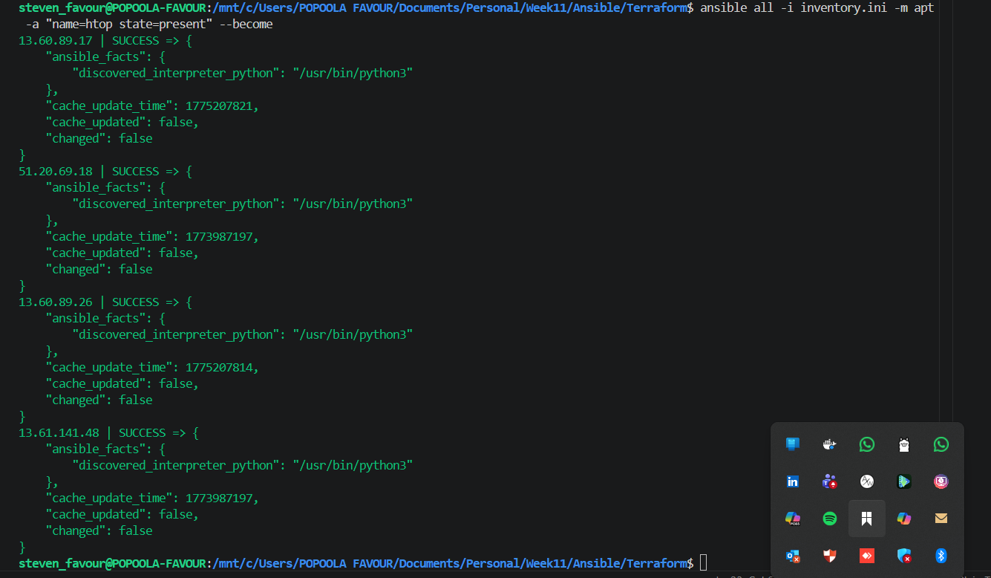

Run htop command to see memory status of these VMs

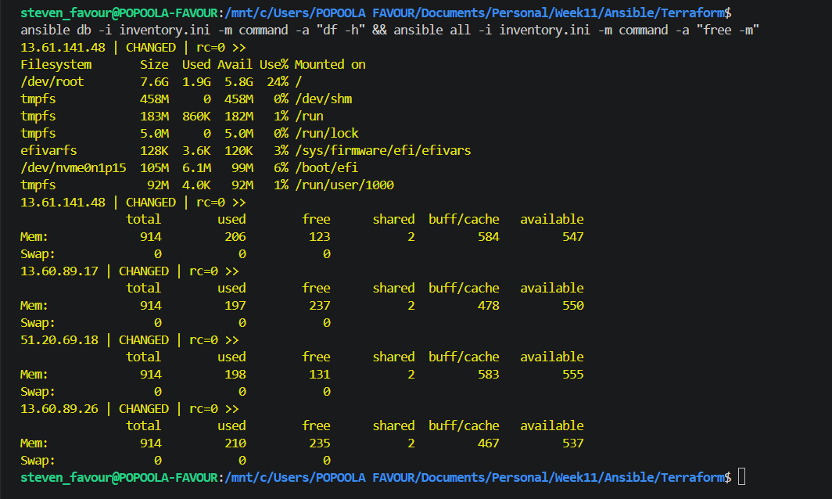

Task 3
Notes:
Screenshots:

Assignment 3: Multi-Play Web Deploy on Azure

Notes should include:
What you did (2–5 lines per task)
What you learned (1–2 lines)
Any issue you faced + how you solved it (if applicable)

Task 1
Notes:
Screenshots:

Task 2
Notes:
Screenshots:

Task 3
Notes:
Screenshots:

Assignment 4: Deploy Mini Finance Project Using Terraform and Ansible

Notes should include:
What you did (2–5 lines per task)
What you learned (1–2 lines)
Any issue you faced + how you solved it (if applicable)

Task 1
Notes:
Screenshots:

Task 2
Notes:
Screenshots:

Task 3
Notes:
Screenshots:

Task 4 — LinkedIn Post (MANDATORY)
Notes:
Publish your LinkedIn post (be creative — do not copy and paste).
Make sure your post is public (or at least “Anyone” visibility).
Screenshots:
Screenshot 1: Screenshot of your LinkedIn post (showing text + at least one link OR image)
Submission (fill these)
Paste LinkedIn Post URL here: ___________________________

Assignment 5: Production-Grade EpicBook — Terraform + Ansible Roles (Azure or AWS)

Notes should include:
What you did (2–5 lines per task)
What you learned (1–2 lines)
Any issue you faced + how you solved it (if applicable)

Task 1
Notes:
Screenshots:

Task 2
Notes:
Screenshots:

Task 3
Notes:
Screenshots:

Task 4 — LinkedIn Post (MANDATORY)
Notes:
Publish your LinkedIn post (be creative — do not copy and paste).
Make sure your post is public (or at least “Anyone” visibility).
Screenshots:
Screenshot 1: Screenshot of your LinkedIn post (showing text + at least one link OR image)
Submission (fill these)
Paste LinkedIn Post URL here: ___________________________

============================================================
SUBMISSION (DMI — ONE GOOGLE DOC)
Create ONE Google Doc for Week 9 using the file name format:
FullName_Week9_GroupX (Example: PravinMishra_Week9_Group3)
Before you submit:
- Ensure all required screenshots are included
- Ensure Full Name is visible in every screenshot (Proof Rule)
- Ensure LinkedIn links are public and clickable
Get the View Link:
- Click Share (top-right corner)
- Under General access: Restricted → Anyone with the link
- Set access to Viewer
- Click Copy link
- Paste the link in the submission form

About DevOps Micro Internship (DMI) & CloudAdvisory
DevOps Micro Internship (DMI) is a free, project-based DevOps learning program by Pravin Mishra (CloudAdvisory). It helps students, job-seekers, and working professionals gain real-world DevOps skills through weekly assignments, projects, and community support.

🌐 DMI Official Website: https://pravinmishra.com/dmi
🎓 DevOps for Beginners: Docker, K8s, Cloud, CI/CD & 4 Projects (Udemy): https://www.udemy.com/course/devops-for-beginners-docker-k8s-cloud-cicd-4-projects/?referralCode=C5BA8236CCE9FE004F98
▶️ DevOps for Beginners – YouTube Playlist: https://www.youtube.com/playlist?list=PLVOdqXbCs7bX88JeUZmK4fKTq2hJ5VS89
🔗 Follow Pravin Mishra on LinkedIn: https://www.linkedin.com/in/pravin-mishra-aws-trainer/

